Killer Sudoku (Colour) 1

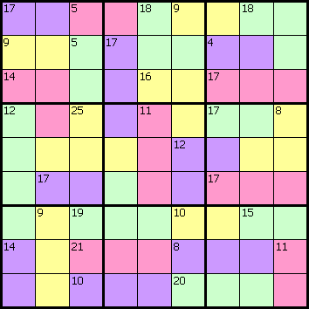

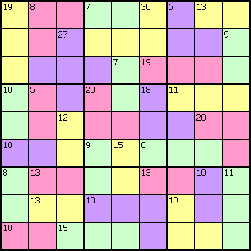

More Killer Sudoku Puzzles can be found at:
www.sudoku.4thewww.com

Killer Sudoku (Colour) Solutions 1

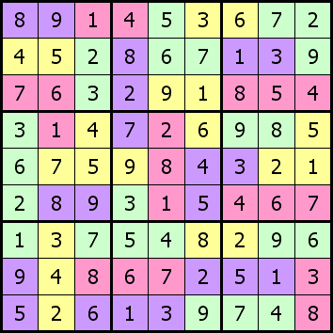

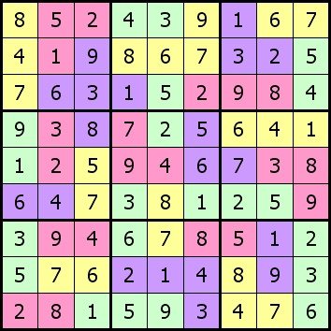

More Killer Sudoku Puzzles can be found at:
www.sudoku.4thewww.com

