Killer Sudoku Solutions

Gentle
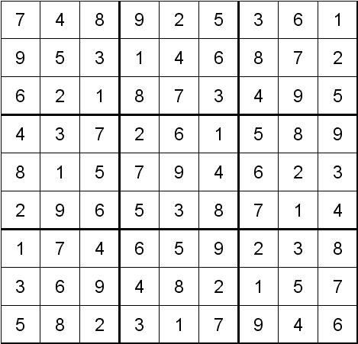

Moderate
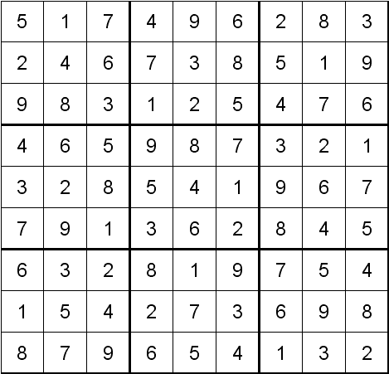

Tricky

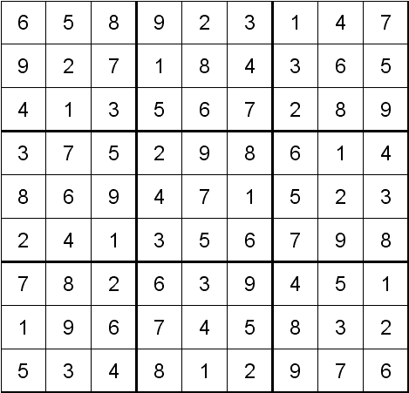

Tough

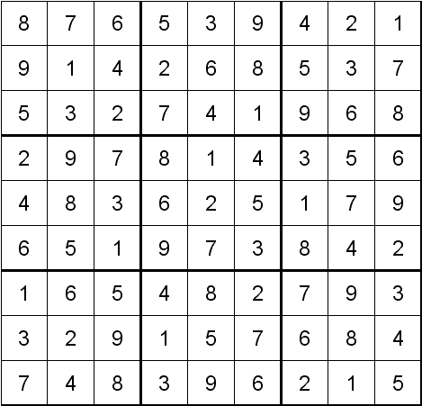

Deadly

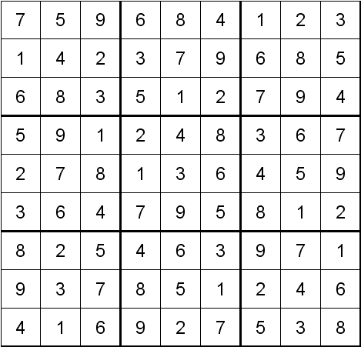

More Killer Sudoku and other Sudoku Puzzles and the solutions can be found at http://www.sudoku.4thewww.com

Enjoy

